STARTUPJET WEBSITE ERROR
- DIN
{FIXED} {THERE IS AN ISSUE WITH DOC. SIZE (mentioned in new bugs1)}
- upload photo Kb size error: 2.5 lakh KB → 250 KB

- Utility bill in Company Registration
{COULD NOT FIND COMPANY REG.}
- Mention in utility bill---Rent agreement, electricity bill, mobile bill, electricity gas
- Explanation of attachments in FAQ.
- {If were talking about LLP here then NOT IMPLEMENTED.}
- Update of application process
{UNABLE TO TEST IMPLEMENTATION,(further info needed)}
- Further update should be mentioned, e.g., 2nd update.
- For creation of logo: Command option should be specified.
{NOT IMPLEMENTED}
- GST
{CAN BE EDITED FROM ADMIN PANEL}
Individual (Proprietor):
- PAN + Aadhaar + Regd. Office rent agreement
- Electricity billS
- Mobile no. & Email
- Picture of business name + Proprietor
- Scan photo of proofs
Company (LLP/Pvt. Ltd./Partnership):
{CAN BE EDITED FROM ADMIN PANEL}
- COI (Certificate of Incorporation) / LLP registration + Board resolution
- Co. PAN + Partners’/Directors’ Aadhaar & PAN , Email + Mobile
- Rent agreement
- Electricity bill
- Photo
- GST Registration application:
- Size issue → 5 MB {EDITABLE}
- In case of rejection → Refund secret code is invalid
{UNABLE TO TEST}
- GST cancellation
- 5KB size issue {EDITABLE}
[ Admin portal – contact user, Email not opening, Call option not working ] {FIXED}

- ITR filing
- Size 5KB, 10KB issue while uploading {EDITABLE}
- Actions – Delete button not working in service submissions
{NO DELETE BUTTON FOUND }
- Find experts
- Date error – month/day/month/year → day/month/year {FIXED}
- Confirmation email to clients while submmiting the form for consulting experts. {IMPLMENTED}
- Trademark availability search
- Classes of goods/services not working/selecting {IS A LIST INSTEAD OF DROPDOWN} {NOT FIXED}
- Search Results
- A 'Back' option is needed on the search results page. {IMPLMENTED}
- Search Filter
- The search filter option needs to be implemented.
{NOT IMPLMENTED}
- Tags
- Tags are not clickable.
{NOT FIXED}
- Card Click
  - The click functionality on the "complete card" inside services should be implemented. {IMPLMENTED}
- Logo
  - The logo is not downloading, or it is downloading very slowly.
{FIXED}
- Booking Cancellation
A booking cancellation and refund option is required.
{NOT IMPLMENTED}
- Services
  - A "Cancel Option" is needed for services.
{NOT IMPLMENTED}
- Post-Payment Editing
  - After payment, provide an option for users to edit their submission details for a limited period of time.
{NOT IMPLMENTED}
- Flowchart
  - The "Flowchart History" option is not working or is not implemented well (redirecting to homepage).
{IMPLMENTED}
- Password Reset
The password reset/update functionality is not working. {FIXED}
- Forgot Password
The email link for "Forgot Password" is not working. {FIXED}
- Analyse My Idea Feature
This feature is missing from the main website and is only available on the landing page. {FIXED}
- Business Planning
  - The "Al Business Planning" section is missing neededin ai tools.
{FIXED}

- Document Size
  - The maximum size for document uploads needs to be increased.
{refer to new bugs1}
- Sitemap
There is an issue with the sitemap (seems to be a problem related to requiring a login). {FIXED}

- Contact Us Page
On the Contact Us page, the hamburger menu is working, but the "About Us" and “Expert” option within it is not. {FIXED}
Admin Panel Issues
- Home Panel
- The home panel option is not working. {FIXED}
- Categories:
  - The 'Add Option' and 'Edit Option' are not working. {FIXED}
  - Categories are not being displayed on the website. {FIXED}
- Services:
- Navigating to Services → Actions → Show results in a site error. {FIXED}
- Pricing:
  - The price is not changing for bookings. {FIXED}
  - The discount is not being applied to all items. {NOT IMPLEMENTED}
  - Many pages are still running in local host. {FIXED}

NEW BUGS
- While editing or creating a service, the upload size only show 1/1000th of what is selected (i.e. shows 10 kb for 10000kb)
- *attached images for reference
- 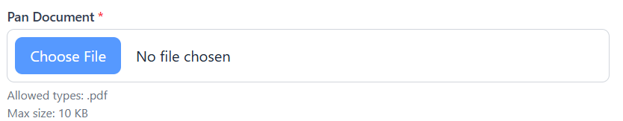Actual size on website
- 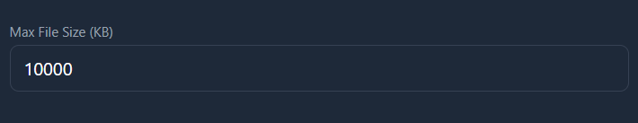size selected on admin panel
Search whiteout bug
searching makes the page completely white, have been able to recreate this bug by searching for din (din is a service we provide so, fixing is needed).
https://drive.google.com/file/d/1fZhlNyjAIa5Z0_vbucww_IWVqB6UenbB/view?usp=drive_link
drive link to video of the bug*
- Every Service and Expert booking need an edit details and delete submission button (after booking).
- On standard zoom,on laptop, the Admin users button gets hidden in admin page,(side panel is not srolling)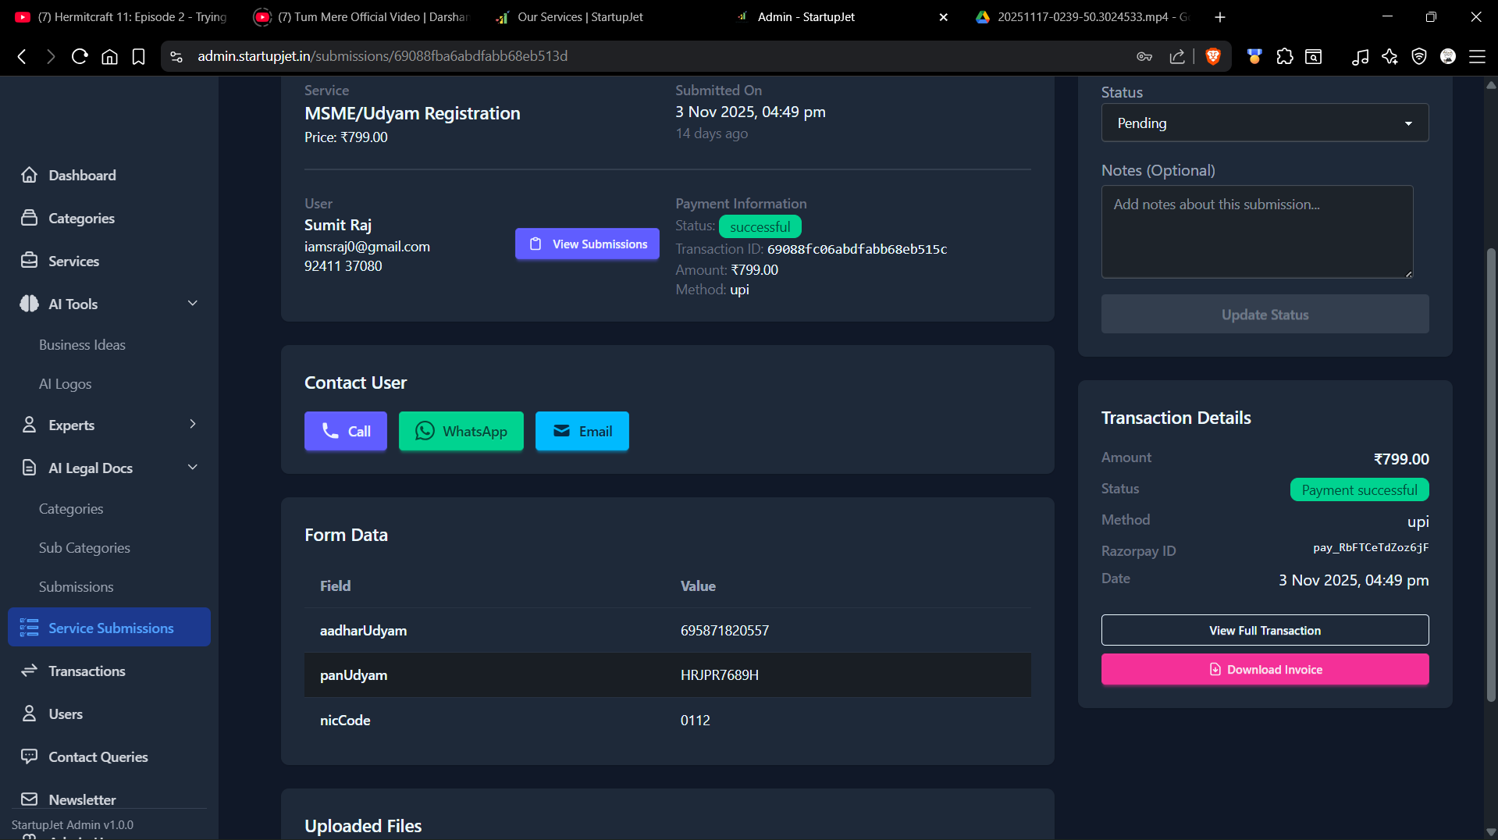
*page on 100% zoom
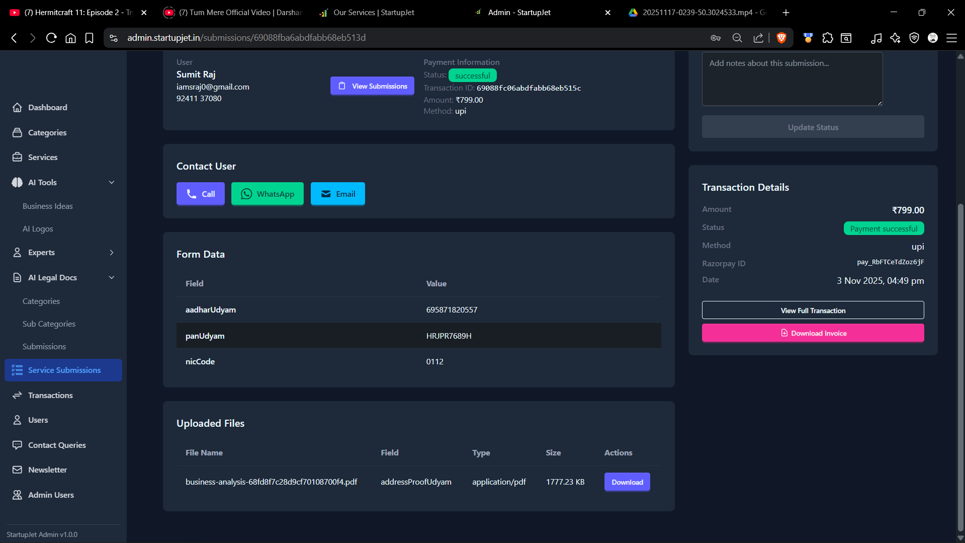*page on 80% zoom
- Miss alignment on mobile screen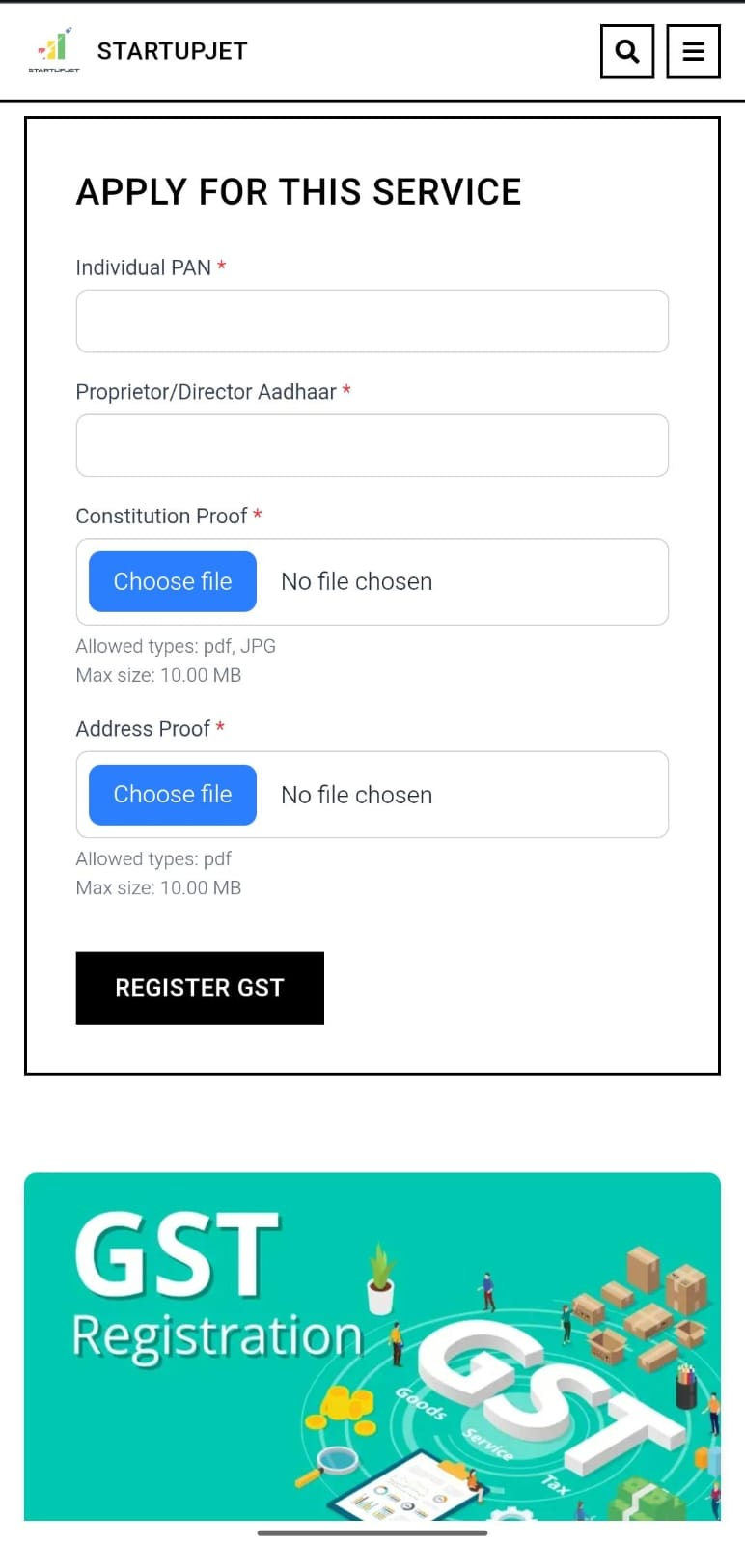

FEATURE REQUESTS:
- Deleteing or Resheduling An expert service booking.
- Option to add FAQ in bulk with option to select which services to be show/select all.
- Different implementation for NRI? Or a NRI help/contact option, for NRIs to use because many forms have different requirements if you are an NRI also a separate NRI FAQ panel or page.
Navigation Highlight issue
- The “view all services” button does not stay active/highlighted after clicking it.
This makes the user confused about whether the page is open.
Please add an active state to show the user’s current page.
2.After clicking the ‘Final Experts ‘ button the page opens but there is no back navigation
Option to return to the previous page.
3.After opening any AI Tool dropdown (AI Logo Generator, Business Idea Analyzer,AI Legal Documents), there is no back or navigation option to return to the main AI Tools page.
User Profile issue
After logging into the website, the user profile icon should appear on the top-right corner of the page. When the user clicks on the profile icon, a dropdown menu should open showing the following options:
- My Profile
- My Services
- My Orders
- Settings
- Help & Support
We should add footer section

